Worth Steel & Machinery, Inc.
4001 West 123rd Street Alsip, IL 60803
(708)388-6300 Fax (708)388-6467

Overhead Payoff System
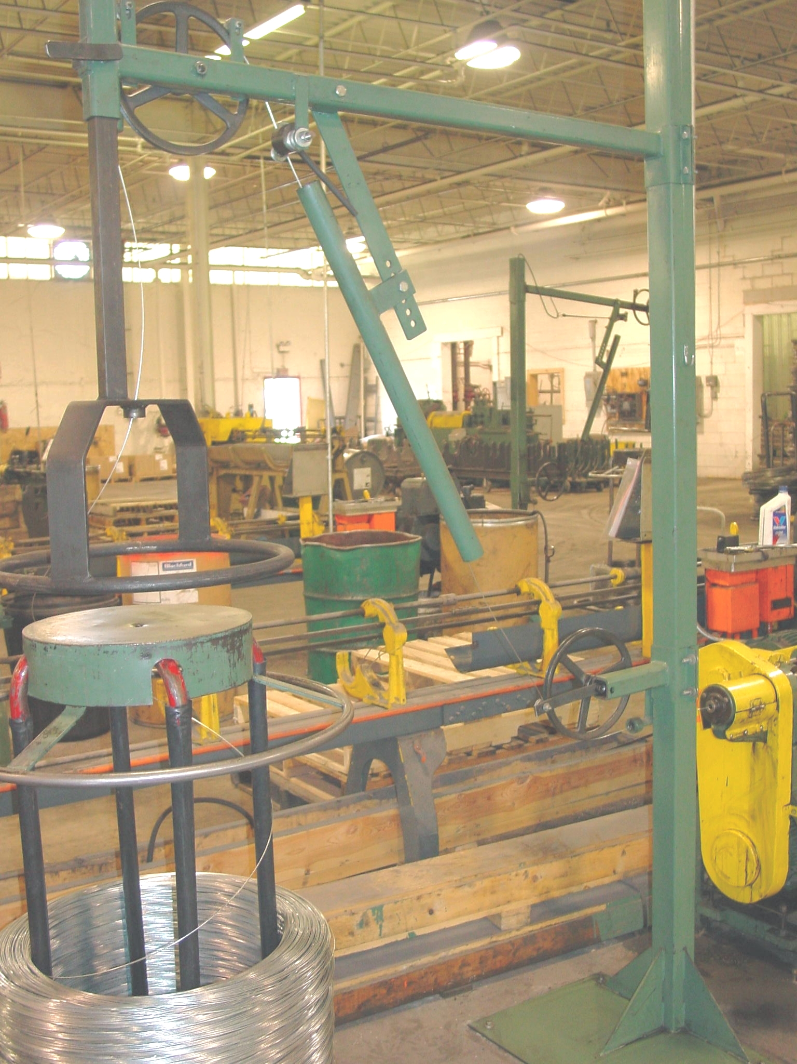
- Ideal for paying off many types of wire - low & high carbon, stainless, spring temper, and Annealed wires
- For use with wire capacities of .125 dia or finer
- In most cases, wire pays off in the same manner in which it was put on
- reduced pulling and dragging - increases production rates by as much as 20%
- when the machine stops the wire stops
- Longer tool life
- Assists in attaining restricted specifications
- Carrier/Coil weight has absolutely no bearing on performance
- minimum floor space required (approx 72” x 48”)
- easy assembly
- quick adjustments for varying machine and packaging heights

F.O.B. our warehouse, Alsip, IL available with a 30 day return privilege Price $ 1750.00 each (quantity discounts available)

