Worth Steel & Machinery, Inc.
4001 West 123rd Street Alsip, IL 60803
(708)388-6300 Fax (708)388-6467
www.worthsteel.com

We are pleased to quote the following:

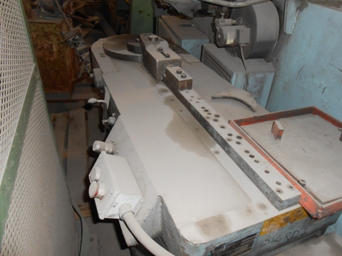

One Used Diacro Hydraulic Rotary Bender

Model 8

Serial 1580478179
Capacity 1” wire. 1 ½ “ O.D. tube w/16 gage wall
Radius 24”
Degree 360
PSI 1000
H.P. 3
Dimensions:
(machine) 32” wide x 60” long x 48” high
Tooling none available
Approx. Weight 1500 lbs.
Condition Good
Stock Number 677

F.O.B. our warehouse, Alsip, IL available with a 30 day return privilege Price $ 5,000.00

