Worth Steel & Machinery, Inc.
4001 West 123rd Street Alsip, IL 60803
(708)388-6300 Fax (708)388-6467
www.worthsteel.com

We are pleased to quote the following:

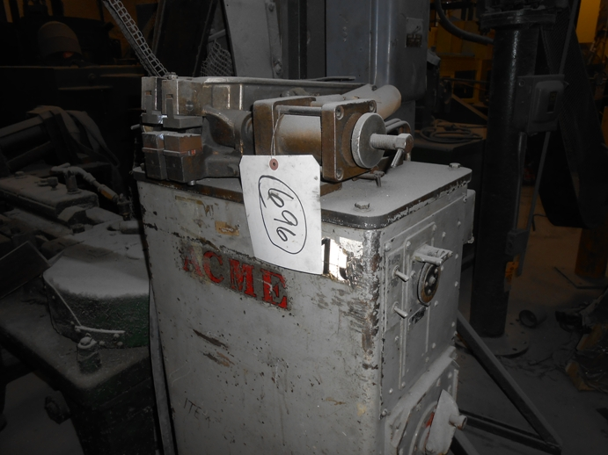

One Used Acme Butt Welder

Model B-01-20

Serial 10415
KVA 20
Volts 220
Type Production
Dimensions:
(machine) 28” wide x 28” long x 48” high
Approx. Weight 800 lbs.
Condition Good
Stock Number 696

Price F.O.B. our warehouse, Alsip, IL available with a 30 day return privilege $ 1,750.00

