Worth Steel & Machinery, Inc.
4001 West 123rd Street Alsip, IL 60803
(708)388-6300 Fax (708)388-6467
www.worthsteel.com

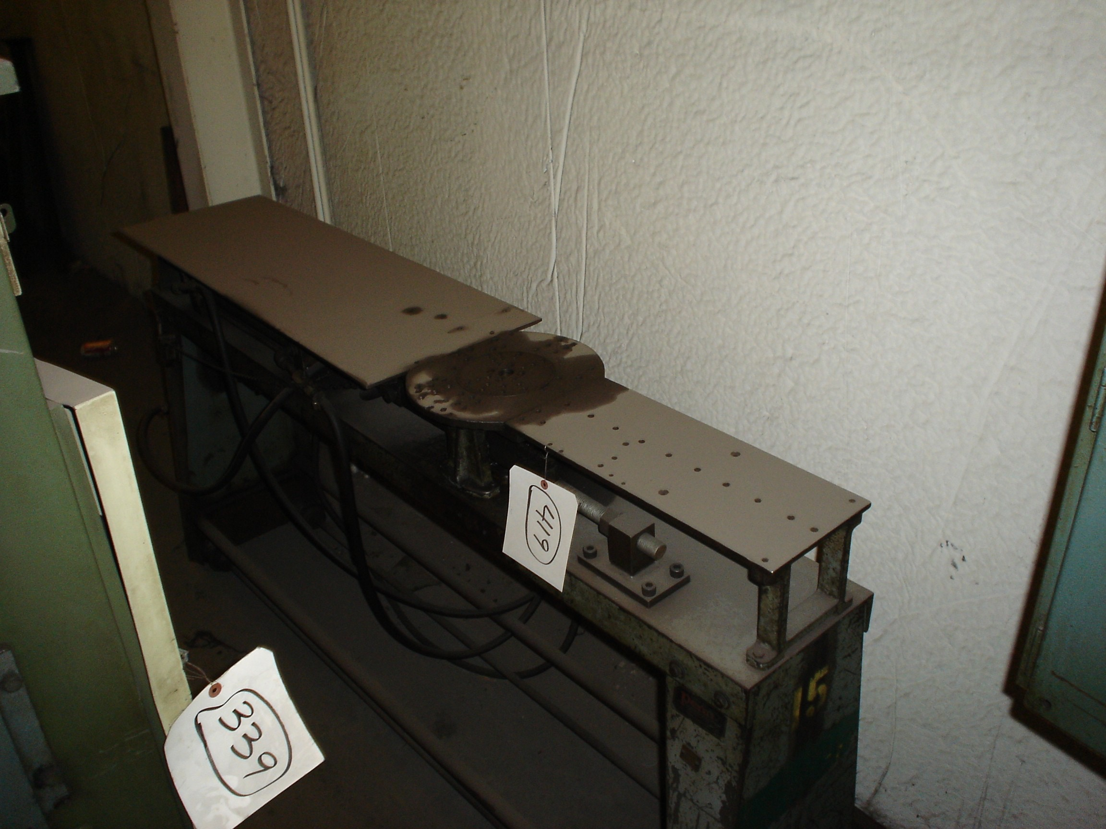
We are pleased to quote the following:

One Used Penn Rotary Bender

Model single stop

Serial N/A
Disc 6”
Dimensions:
(machine) 24” wide x 72” long x 48” high
Tooling none
Approx. Weight 1000 lbs.
Condition Good
Stock Number 419

F.O.B. our warehouse, Alsip, IL available with a 30 day return privilege Price $ 2,500.00

