Worth Steel & Machinery, Inc.
4001 West 123rd Street Alsip, IL 60803
(708)388-6300 Fax (708)388-6467
www.worthsteel.com

We are pleased to quote the following:

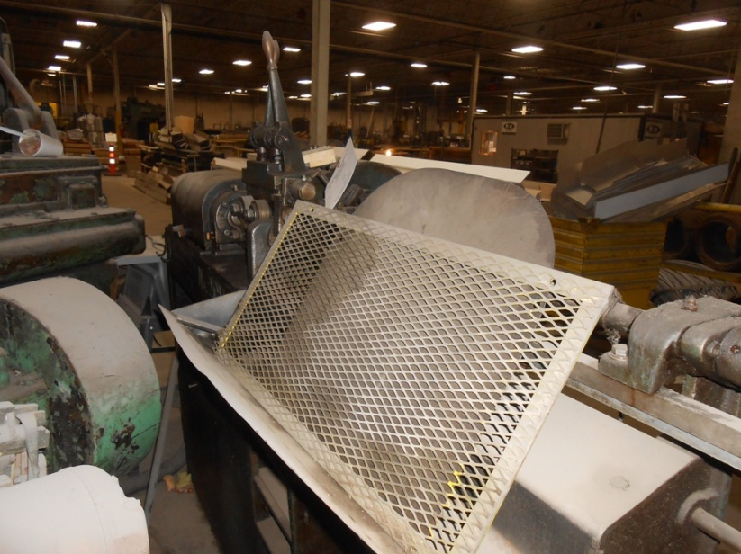

One Used Lewis Straighten and Cut Machine

Model 2CV5

Serial 128
Capacity .062 - .312
Bed 72”
H.P. 10
Year 1957
Feed Rolls 2 after the arbor
Dimensions:
(machine) 36” wide x 96” long x 48” high
Tooling 1 set included
Approx. Weight 1800 lbs.
Condition Good
Stock Number 726

Price F.O.B. our warehouse, Alsip, IL available with a 30 day return privilege $ 12,500.00

