Worth Steel & Machinery, Inc.
4001 West 123rd Street Alsip, IL 60803
(708)388-6300 Fax (708)388-6467
www.worthsteel.com

We are pleased to quote the following:

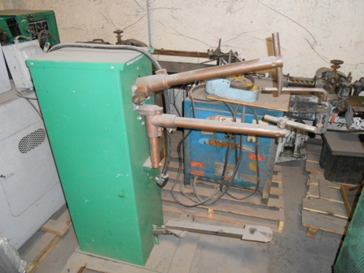

One Used Western Arctronics Spot Welder

Serial FF084
Type Rocker
Throat 24”
KVA 30
Volts 220
Control Old
Dimensions:
(machine) 24” wide x 40” long x 52” high
Approx. Weight 850 lbs.
Condition Good
Stock Number 686

Price F.O.B. our warehouse, Alsip, IL available with a 30 day return privilege $ 2,000.00

