Worth Steel & Machinery, Inc.
4001 West 123rd Street Alsip, IL 60803
(708)388-6300 Fax (708)388-6467
www.worthsteel.com

We are pleased to quote the following:
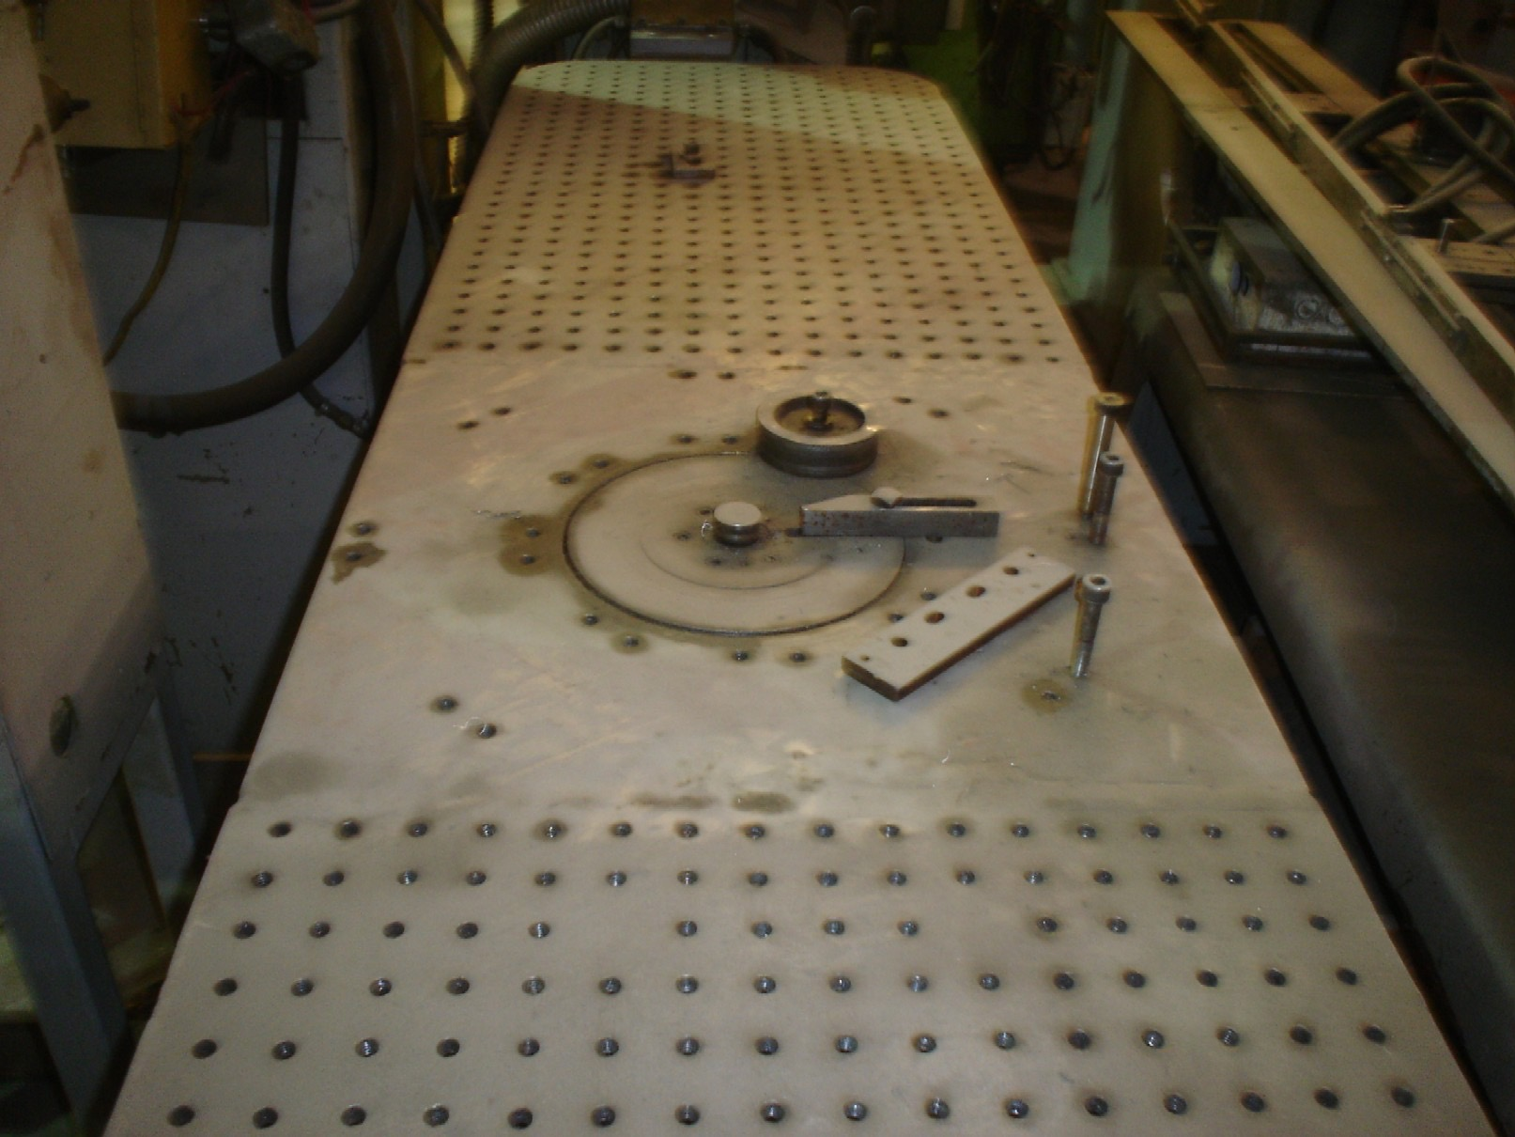

One Used Custom Rotary Bender

Model N/A

Serial N/A
Capacity .500 capacity
Operation Air
Year N/A
Dimensions:
(machine) 32” wide x 84” long x 48” high
Tooling 1 set included
Approx. Weight 800 lbs.
Condition Good
Stock Number 509

F.O.B. our warehouse, Alsip, IL available with a 30 day return privilege Price $ 3,500.00

