Worth Steel & Machinery, Inc.
4001 West 123rd Street Alsip, IL 60803
(708)388-6300 Fax (708)388-6467
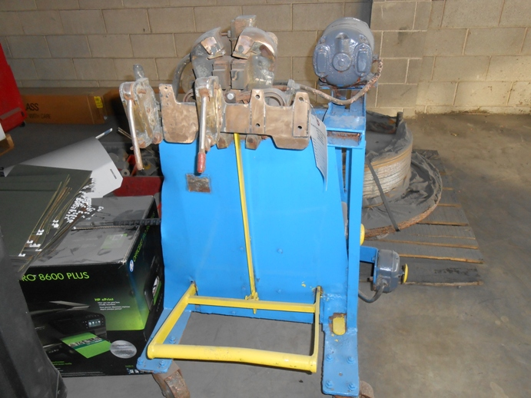

We are pleased to quote the following:

One Used Micro Butt Welder

Model J6

Serial 6078
Capacity .125 - .375
Volts 220
Dimensions:
(machine) 24” wide x 12” long x 42” high
Approx. Weight 800 lbs.
Condition Good
Stock Number 713

Price F.O.B. our warehouse, Alsip, IL available with a 30 day return privilege $ 4,500.00

