Worth Steel & Machinery, Inc.
4001 West 123rd Street Alsip, IL 60803
(708)388-6300 Fax (708)388-6467
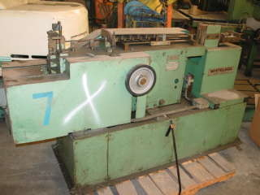

We are pleased to quote the following:

One Used Whitelegg Wire Forming Machine

Model SCR 2

Serial 248
Capacity .080 - .160
H.P. 1.5
Year 1977
Dimensions:
(machine) 24” wide x 84” long x 48” high
Tooling 1 set included
Approx. Weight 1600 lbs.
Condition Good
Stock Number 352

F.O.B. our warehouse, Alsip, IL available with a 30 day return privilege Price $ 5,000.00

